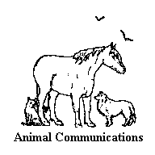
ANITA CURTIS
ANIMAL COMMUNICATIONS
P O BOX 182
GILBERTSVILLE, PA 19525-0182
(610) 327-3820

HOW TO HEAR THE ANIMALS LEVEL I & II

Level I - Saturday, March 21, 2020
Level II - Sunday, March 22, 2020 Registration: 9:00-9:30 am
Fee: $130 for each day Workshop: 9:30 a.m.-4:30 p.m.
These times are for both days.

Location: Hunterdon County Extension Center, Flemington, N.J. Directions will be sent when registration is received

LEVEL I

Have you ever wished you could understand what your animal friend was thinking or wanted to tell you? Join us at this workshop and learn techniques you can use to increase your ability to communicate with animals. You will enhance your relationship with your animal friends and better understand their needs, feelings, behavior and problems.
The workshop will help you recognize times you have already experienced telepathic communication with animals. You will:
•Participate in exercises and meditations which increase your receptivity to telepathic communication.
• Learn how to quiet and focus your mind.
• Practice sending and receiving telepathic communications - first with a human partner, then with animals.
Penelope Smith, a pioneer in animal communications, first developed this workshop, which has been successfully taught to thousands; and Penelope has authorized Anita Curtis to teach her techniques. Anita’s students have included veterinarians, farriers, trainers, animal massage therapists, and other animal professionals - as well as hundreds of pet owners, just like you.

LEVEL II

This workshop is designed to enhance and broaden the skills learned in Level I. You must attend Level I before taking this workshop. You will:
•Explore the viewpoints and feelings from within a specific animal.
•Learn the technique of contacting departed animals.
•Be introduced to some Native American customs, and learn about rocks and crystals.
•Learn about rocks and crystals and their connections to us and to the Universe.

Our animal friends will not be needed in person at this workshop. Please bring 3 photographs of living animals for Level I and 3 each of living and departed animals for level II. The photos do not have to be recent or clear, but they must be of your own animals or animals you know very well.
A deposit of $50 for each workshop — check payable to Anita Curtis. Payment may be made through PayPal (even if you do not have a PayPal account) and is due by March 14, the balance is due at the workshop. PayPal registration can be handled by phone (610-327-3820) or by e mail at anitacurtis123@aol.com. Mail check and registration form to Anita Curtis, P O Box 182, Gilbertsville, PA 19525 or online at www.anitacurtis.com, gift certificates and deposits. Click onto consultation deposit.
SPACE IS LIMITED — PLEASE SEND YOUR REGISTRATION IN EARLY. [Deposits are non-refundable except in the event the workshop is cancelled, or if you cancel your registration 2 weeks prior to the workshop. Deposits may be transferred to another workshop.]

REGISTRATION FORM HOW TO HEAR THE ANIMALS

PLEASE CHOOSE DATES YOU WANT TO ATTEND
LEVEL I ( ) March 21, 2020 LEVEL II ( ) March 22, 2020

You must take Level l before you take Level ll

NAME______________________________________________________________
ADDRESS: __________________________________________________________________
__________________________________________________________________

PHONE:___________________________________________________________

EMAIL ADDRESS____________________________________________________

For every attendee $50 will be donated to Team Velvet.
About Team Velvet:
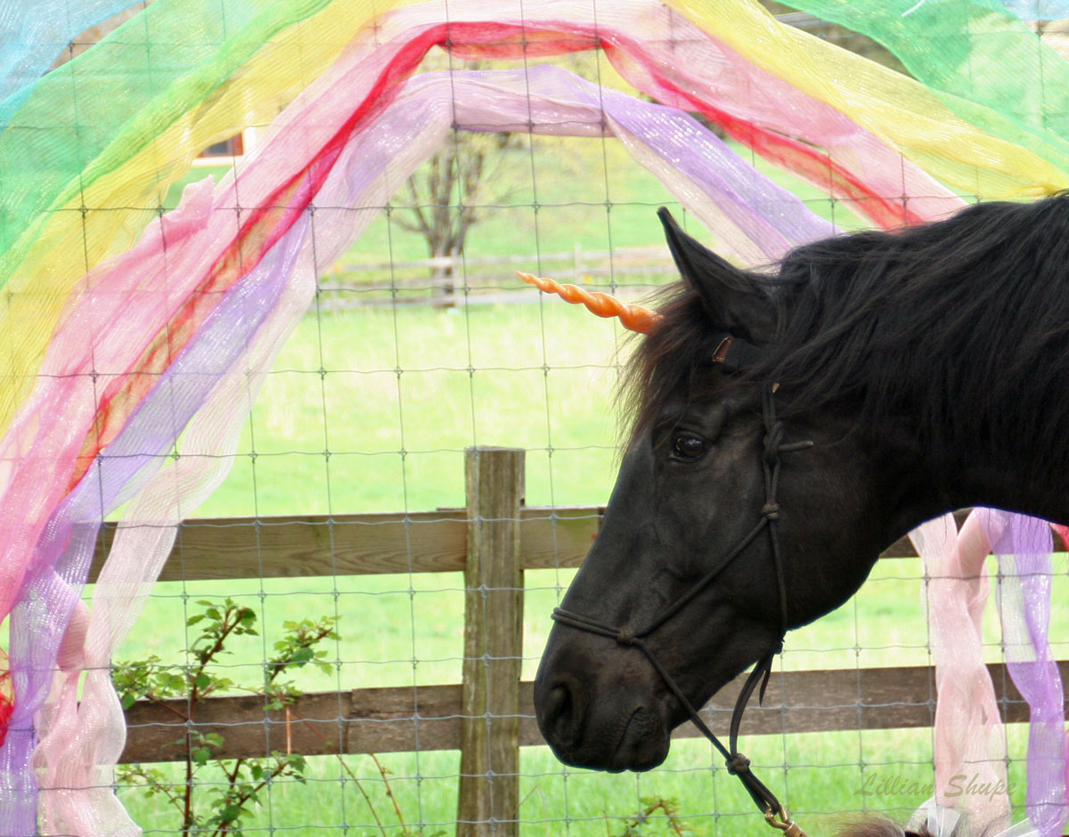
Each day there is a child who experiences the death of a loved one, is a witness to violence, is victimized by crime or intense bullying, is disfigured by an accident, or experiences countless other events — all resulting in severe childhood trauma.
If left unaddressed, in the extreme, child trauma may cause flashbacks, blackouts, and may result in severe damage.
Team Velvet, Inc. provides multi-modal horse therapy for traumatized children ages 5 to 12 years with psychologist Dr. Susan Edwards. Therapy horses may be involved in interactive games, kick a soccer ball, dance or be taught liberty performance. Children do not ride the horses; they interact while working toward goals of increased self-esteem and resiliency.

